Execution Plan on DB1(Oracle 9.2.0.7 on Linux with 2 CPU)
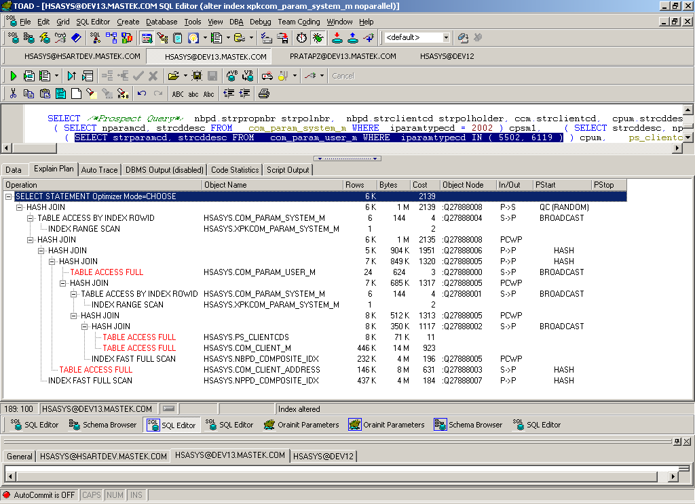

Execution Plan on DB2(Oracle 9.2.0.6 on Linux with 2 CPU)

